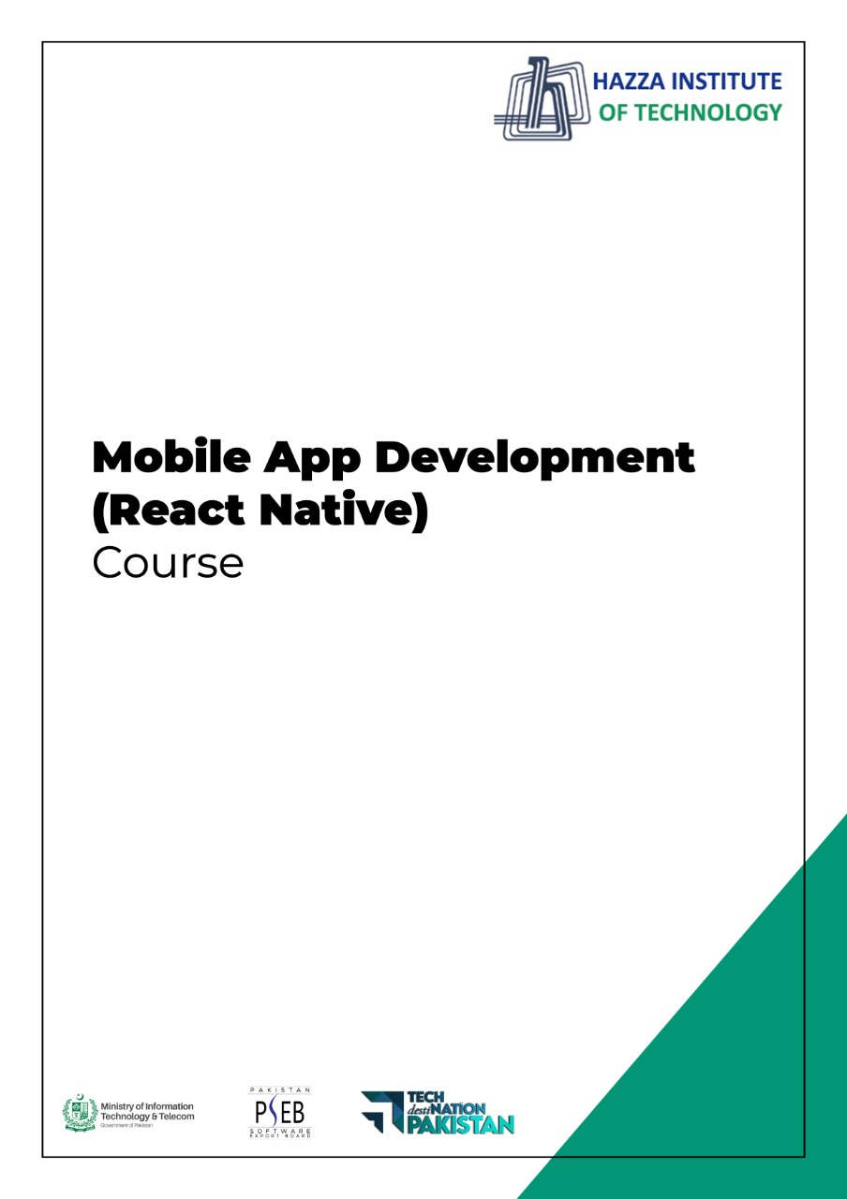

**(Flutter)**

Flutter Lab 4 (Session 1)

**Total Time:**

**3 hours (session-1)**

**Pre-Lab Activities:**

* + Students should familier with layout widgets
  + Student should complete week three slides before these labs

**Learning Outcomes:**

* + Student will learn about Layout Design
  + Student will learn single/multiple child widgets

**Student Activities:**

* + Student use the Android Studio
  + Student will get familiar with different Button styles
  + Student use different layout widget to desgin UI

**Lab Tasks 1:**

Design following button accoridng to formate given in figure

* + 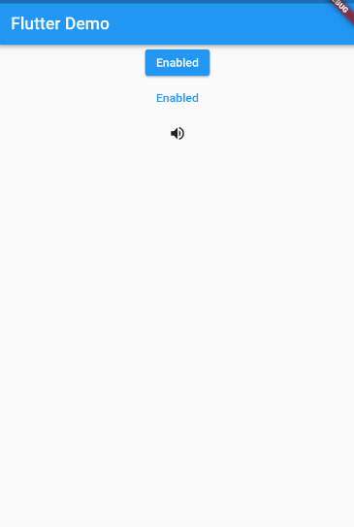Elevated button
  + Text Button
  + Icon button

**Lab Tasks 2:**

* + Design below layout by using Expand and flex , assign flex value 2 to yellow container and 1 to blue container to achieve this design

**Lab Solutions:**

**LAB 4.1 : Practicing Button Designing.**

|  |
| --- |
| import 'package:flutter/material.dart';  void main() => runApp(MaterialApp(  title: 'Flutter Demo',  theme: ThemeData(  primarySwatch: Colors.blue,  ),  home: Scaffold(  appBar: AppBar(  title: Text('Flutter Demo'),  ),  body: Center(  child: Column(    children: <Widget> [  ElevatedButton(  onPressed: () {}, child: Text('Enabled'),  ),  TextButton(  onPressed: () { },  child: Text('Enabled', style: TextStyle(color: Colors.blue)),  ),  IconButton(  icon: Icon(Icons.volume_up), onPressed: () { },  ),  ],  ),  ),  ),  )); |

**LAB 4.2 : Practicing Layout Design.**

|  |
| --- |
| import 'package:flutter/material.dart';  void main() => runApp(MaterialApp(  home: Scaffold(  appBar: AppBar(  title: Text('Flutter Demo'),  ),  body: Center(  child: Column(  crossAxisAlignment: CrossAxisAlignment.stretch,  mainAxisAlignment: MainAxisAlignment.center,  children: <Widget> [  Expanded(  child: Container(  color: Colors.blue,  ),  ),  Expanded(  child: Container(  color: Colors.orange,  ),  ),  Expanded(  child: Container(  color: Colors.blue,  ),  )  ],  ),  ),  ),  )); |